2010 H2 Chemistry Preliminary Exams
Paper 3: Suggested Answers

1 | (a) | (i) | - Low temperature favours forward reaction which is exothermic. This gives high yield of SO₃.  - But equilibrium is attained at a lower rate at low temperature.  - A moderately high temperature is used to achieve equilibrium more rapidly (together with a catalyst to increase the rate).  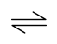
 |  | (ii) | 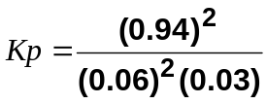  = 8180 atm⁻¹ (3 sf)
   | 2SO₂ (g) + | O₂(g) |  | 2SO₃(g)
  Initial partial pressure / atm | 1.0 | 0.5 |  | −
  Change in partial pressure / atm | -0.94 | -0.47 |  | +0.94
  Eqm partial pressure / atm | 0.06 | 0.03 |  | 0.94
 |  | (iii) | - when volume is reduced, pressure is increased  - by Le Chatelier’s Principle, equilibrium position shifts right to the side with fewer gaseous molecules  - percentage conversion of SO₂ into SO₃ increases
 | (b) | (i)
  A
  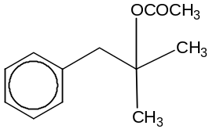
  B and C
  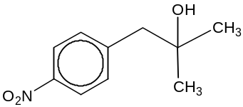 | 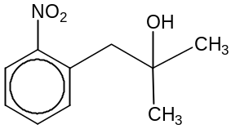
  D and E
  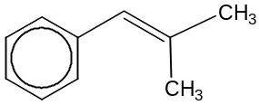 | 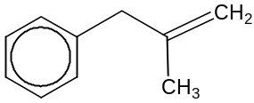
 |  | (ii) | The N of NO₂⁺ is electron-deficient species which attacks electron-rich benzene ring and accepts a pair of electrons from benzene.
 |  | (iii) | HNO₃ + 2H₂SO₄ ⇌ NO₂⁺ + H₃O⁺ + 2HSO₄⁻
 |  | (iv) | lone electron pair on O of OH group is delocalised into the benzene ring, which strongly activates the benzene ring / increases electron density of benzene
 | (c) | (i) | LiAlH₄ in dry ether
 |  | (ii) | K: CH₃CH(OH)CH₂OH  L: CH₂=CHCH₂OH
  Info | Deduction | Type of reaction
  K passes over hot Al₂O₃ | – | dehydration / elimination
  L does not react with 2,4-DNPH | Q does not have carbonyl group | –
  L decolourises Br₂(aq) | – | electrophilic addition
  L gives CO₂(g) with KMnO₄(aq) | Q has terminal alkene / =CH₂ group | oxidation
2 | (a) | (i) | 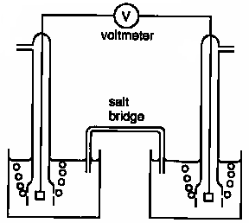  graphite  graphite  1 mol dm⁻³  NaOH(aq)  O₂(g), 25ºC, 1 atm  H₂(g), 25ºC, 1 atm  Cathode (+)  Anode (–)  1 mol dm⁻³  NaOH(aq)  e⁻ flow
 |  | (ii) | Anode: H₂(g) + 2OH⁻(aq) → 2H₂O(l) + 2e⁻ E^{Ө}_{oxd} = + 0.83 V  Cathode: O₂(g) + 2H₂O(l) + 4e⁻ → 4OH⁻(aq) E^{Ө}_{red} = + 0.40 V  E^{Ө}_{cell} = +1.23 V > 0, reaction is energetically feasible
 |  | (iii) | - When acid is added, the [OH⁻] decreases.  - Position of the equilibrium O₂(g) + 2H₂O(l) + 4e⁻ ⇌ 4OH⁻(aq) shifts to the right.  - E_{red} increases.  - Hence, E_{cell} increases.
 |  | (iv) | constant rate
 | (b) | (i) | Br₂(aq) + 2NaAt(aq) → 2NaBr(aq) + At₂(s)  Black solid astatine deposited
 |  | (ii) | AgNO₃ (aq) + NaAt (aq) → AgAt(s) + NaNO₃(aq)  (Yellow) Solid AgAt would precipitate out and it is insoluble in excess aqueous ammonia
 |  | (iii) | NaAt(s) + H₂SO₄(l) → NaHSO₄(s) + HAt(g)  2HAt(g) + H₂SO₄(l) → At₂(s) + 2H₂O(l) + SO₂(g)  8HAt(g) + H₂SO₄(l) → 4At₂(s) + H₂S(g) + 4H₂O(l)  White fumes of HAt, black solid of At₂ and pungent gas of H₂S formed
 | (c) | 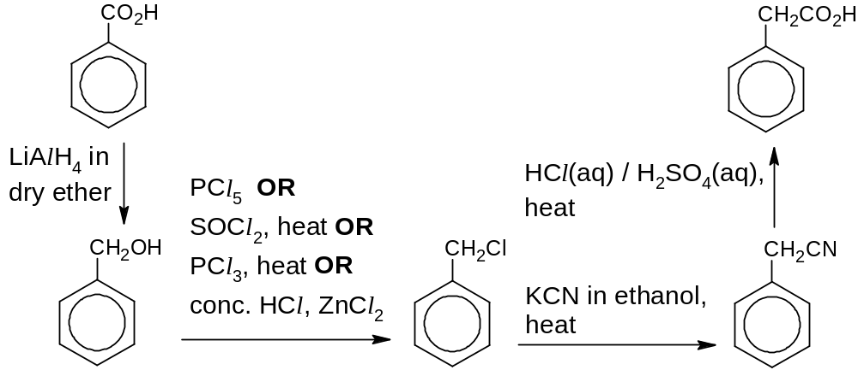
3 | (a) | (i) | A buffer solution is one which tends to resist changes in pH (on dilution or) on addition of small quantities of acid or alkali.
 |  | (ii) | 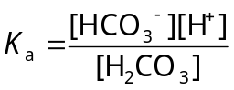  pH = 7.4 ⇒ [H⁺] = 10 ^{−7.4} mol dm⁻³  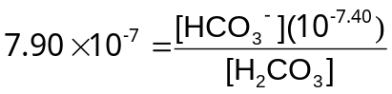  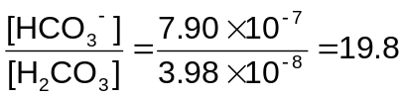
 |  | (iii) | H⁺(aq) + HCO₃⁻(aq) → H₂CO₃(aq)
 |  | (iv) | When lactic acid is released, H⁺(aq) + HCO₃⁻(aq) → H₂CO₃(aq)  H₂CO₃(aq) ⇌ CO₂(aq) + H₂O(l) ----- (1)  When [H₂CO₃] increases, equilibrium position in (1) shifts right, forming more CO₂(aq).  CO₂(aq) ⇌ CO₂(g) ----- (2)  Increase in [CO₂(aq)] will result in equilibrium position in (2) to shift to the right, forming more CO₂(g) and thus resulting in higher rate of breathing.
 | (b) | (i) | Total no. of mol of hydroxide ions = 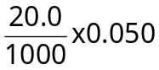 = 1.00 x 10⁻³ mol  [OH⁻] = 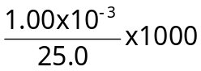 = 0.0400 mol dm⁻³
 |  | (ii) | No. of mol of OH⁻ from NaOH = 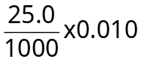 = 2.50 x 10⁻⁴ mol  No. of mol of OH⁻ from Ca(OH)₂ = 1.00 x 10⁻³ – 2.50 x 10⁻⁴  = 7.50 x 10⁻⁴ mol  [OH⁻] from Ca(OH)₂ = 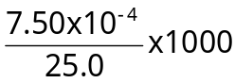 = 0.0300 mol dm⁻³
 |  | (iii) | [Ca²⁺] = 0.0300 /2 = 0.0150 mol dm⁻³
 |  | (iv) | K_{sp} = [Ca²⁺]_{eqm} [OH⁻]_{eqm}²  = (0.0150) (0.0400)² = 2.40 x 10⁻⁴ mol³ dm⁻⁹
 | (c) | (i) | - reagents and conditions: I₂, NaOH (aq), warm  Observation with lactic acid: Yellow ppt of CHI₃ formed  Observation with glycolic acid: No yellow ppt formed  OR  reagents and conditions: KMnO₄(aq), H₂SO₄(aq), heat  Observation with lactic acid: Purple KMnO₄ decolourises without effervescence of colourless gas  Observation with glycolic acid: Purple KMnO₄ decolourises with effervescence of colourless gas  - reagents and conditions: neutral FeCl₃(aq)  Observation with glycolic acid: No violet complex formed  Observation with salicylic acid: violet complex formed  OR  reagents and conditions: Br₂(aq)  Observation with glycolic acid: Reddish brown Br₂(aq) remains  Observation with salicylic acid: Reddish brown Br₂(aq) decolourised
 |  | (ii) | 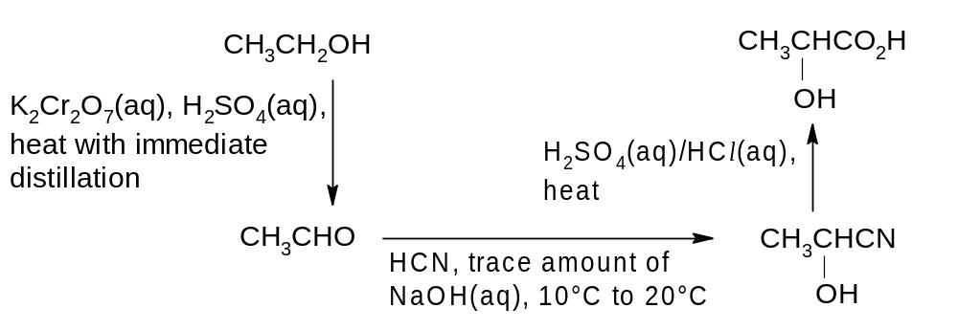
 |  | (iii) | 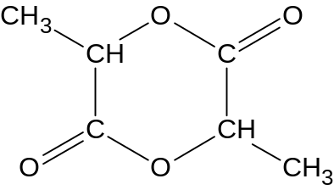
4 | (a) | (i) | Melting points of transition metals are higher than that of calcium. (This is due to stronger metallic bond formed between the transition metal cations and the ‘sea of delocalised electrons’ compared to calcium metal.)  Transition metals have higher density than s-block elements (because transition metals have close-packed structures and relatively smaller atomic radii.)
 |  | (ii)
  sub-atomic particles | number | relative charge | location
  protons | 27 | +1 | in nucleus
  neutrons | 32 | 0 | in nucleus
  electrons | 27 | -1 | in orbitals / outside the nucleus
 |  | (iii) | Calcium can only form a +2 oxidation state because there is a huge energy difference from the 2nd ionisation energy of calcium to the 3rd ionisation energy of Ca or any subsequent removal from the inner shell 3p electrons, which is closer to nucleus, would require more energy to remove. Co can form variable oxidations due to small energy difference between 3d and 4s orbital.
 | (b) | (i) | Let mass be 100 g.
Element: | Co | N | H | Cl
Mass / g | 25.2 | 24.0 | 5.1 | 45.7
Amt / mol | 0.428 | 1.71 | 5.1 | 1.29
Mole ratio | 1 | 4 | 12 | 3

Empirical formula is CoN₄H₁₂Cl₃.

 |  | (ii) | Amount of AgCl precipitated = 9.97 x 10⁻³ mol
 |  | (iii) | No. of free Cl⁻ ion from X that reacted with Ag⁺ ions = 9.97 x 10⁻³ / 0.01  = 0.997 ≈ 1  There are 4 NH₃ and 2 Cl⁻ ligands surrounding the cobalt ion.  Structural formula is [Co(NH₃)₄Cl₂]⁺ Cl⁻. (reject [Co(NH₃)₄Cl₂]⁺)
 |  | (iv) | Oxidation state of Co = +3
 | (c) | - Blue ppt formed is Co(OH)₂.  Co²⁺(aq) + 2OH⁻(aq) ⇌ Co(OH)₂(s)  - On adding excess NH₃(aq), pink [Co(H₂O)₆]²⁺ undergoes ligand exchange to form a soluble complex [Co(NH₃)₆]²⁺, which accounts for the pale brown solution.  - [Co(NH₃)₆]²⁺ → [Co(NH₃)₆]³⁺ + e⁻ E^{ө} = -0.11 V  ½O₂ + H₂O + 2e → 2OH⁻ E^{ө} = +0.40 V  2[Co(NH₃)₆]²⁺ + ½O₂ + H₂O → 2[Co(NH₃)₆]³⁺ + 2OH⁻  E^{ө}_{cell} = +0.40 – 0.11 = +0.29 V > 0, reaction is energetically feasible
 | (d) | (i) | NaOH(aq), heat  C-F bond is stronger than C-Cl bond.
 |  | (ii) | CFCs will cause ozone depletion by undergoing photochemical / free radical substitution reactions with O₃.  Substitute CFC with HCFC OR Liquid Petroleum Gas as propellant in aerosol sprays OR replace aerosol sprays with manual pump sprays.
5 | (a) | (i) |  | 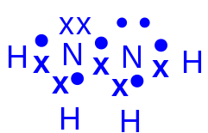107°  trigonal pyramidal about each N atom
 |  | (ii) |  | 
 | (b) | Both ethene and hydrazine are covalent compounds with simple molecular structure. Hydrazine is a polar compound with hydrogen bonds as the intermolecular forces of attraction while ethene has van der Waals’ (id-id interactions). More energy is needed to overcome the hydrogen bonds in hydrazine. Hence, the melting and boiling points of hydrazine are much higher than those in ethene.
 | (c) | (i) |  | NO₂(g) → NO(g) + ½O₂(g)
 |  | (ii) |  | According to the equation in (b)(i), number of moles of gaseous products is more than the number of moles of gaseous reactants OR there is an increase in number of moles of gases.  Thus, entropy increases since there are more particles moving randomly and more ways to distribute the particles and energy. Hence, ΔS > 0.
 |  | (iii) |  | NO₂ (g) → NO(g) + ½O₂(g)  ΔH^{θ} = ΣmΔH^{θ}_{f} (products) - ΣnΔH^{θ}_{f} (reactants)  = +90.3 – 33.2 = + 57.1 kJ mol⁻¹  ΔG^{θ} = ΔH^{θ} – TΔS^{θ}  = +57.1 – 298 (+73.3/1000) = +35.3 kJ mol⁻¹  Since ΔG ^{θ} > 0, the decomposition is not feasible.
 | (d)
Question | Deductions | Type of reactions
Compound Q, C₁₁H₁₂OBr₄, is formed as a minor product when aqueous bromine is added to P. | – | electrophilic addition
P forms a white precipitate upon reaction with aqueous bromine. | P has a phenol group. | electrophilic substitution
When heated with acidified potassium manganate, P gives Compounds R, C₄H₈O, and S, C₇H₆O₃. | P has alkene group. | oxidation
Compound R produces an orange precipitate when reacted with 2,4-dinitrophenylhydrazine. | R has ketone group. | condensation
R also gives yellow precipitate when treated with aqueous alkaline iodine. | R has 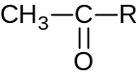structure (and the yellow ppt is CHI₃.) | (oxidation)
2 moles of S reacts with 1 mole of sodium carbonate. | One S has one carboxylic acid group. | (acid-carbonate)
1 mole of S reacts with sodium metal to produce 1 mole of hydrogen gas. | One S has one phenol and one carboxylic acid group. | (acid-metal)
S reacts with phosphorous pentachloride to form Compound T. | – | nucleophilic substitution
Structures:
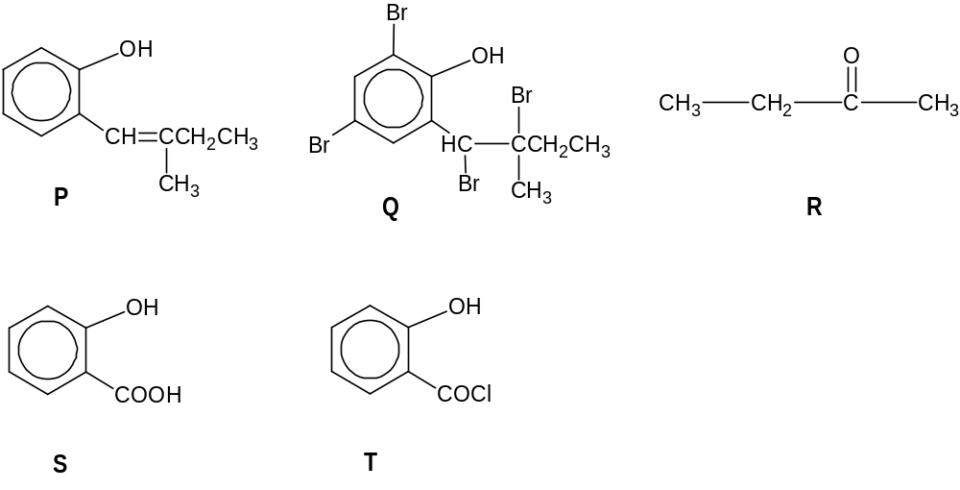

(either isomer of position 1,2 or 1,4 are acceptable)

